Distant Stars Lesson Plan

Time: 40 minutes

Goals: To gain an understanding of the distance to far away stars and the methods used to calculate distance.

Objectives: Students will:
- Watch the “Distant Stars” segment of the “How far away is it” video book
- Optionally, find Ch Cygni on the Chandra Space Observatory website.
- Calculate a star’s luminosity using the H-R Diagram
- Take a short quiz

Materials:
- Internet connection with a computer for viewing “Distant Stars” segment on YouTube

Directions:
- Introduce the Distant Stars segment as our first step beyond the reach of parallax. Point out that we’ll be adding two key rungs to our distance ladder called the H-R Diagram and Standard Candles.
- Show the video.
- Review what they saw:
- How light carries energy.
- How matter changes color as it gets hotter.
- How spectral analysis works.
- How the H-R Diagram helps determine a star’s distance.
- What a Standard Candle is.

- Look up Ch Cygni on the Chandra Space Observatory website.
- With a computer connection, go to http://chandra.harvard.edu/
  - Enter “Ch Cygni” into the search box in the upper right and click go.
  - Select the Ch Cyg item out of the returned list.
  - Review the highlights about the star:
    - What a symbiotic star system is
    - How fast the system’s jet streams are moving.
  - Point out that there is a wealth of additional information not included in the ‘How far away is it’ video.

Assessment options: Here are two assessment options:
- Take a simple quiz. Print and distribute the quiz on page 4. Here are the answers:
    - What is the one factor that determines a star’s color? Answer: b) Its temperature
    - On the H-R Diagram, most stars fall on the diagonal line from the upper left hot blue stars to the lower right cool red stars. What is the name for stars that fall on this line? Answer: d) Main Sequence
    - What element does Helium fusion create that turns stars red? Answer: b) Carbon

- Using the H-R Diagram, estimate the intrinsic luminosity for Rigel:

Here are the basic luminosity classes:

Luminosity class | Description
I | Supergiant
II | Giants
III | Normal giants
IV | Subgiant
V | Main-sequence (dwarf) star

Rigel has a temperature of 12000⁰ and a luminosity class of I.

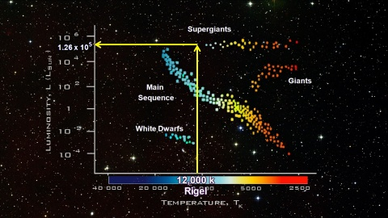

This exercise is repeated without the solution on page 5.
Distant Stars quiz
    - What is the one factor that determines a star’s color?
- Its distance
- Its temperature
- Its red shift
- Its rotational velocity
- On the H-R Diagram, most stars fall on the diagonal line from the upper left hot blue stars to the lower right cool red stars. What is the name for stars that fall on this line?
          - Supergiant
          - White dwarf
          - Runaway
          - Main sequence

  - What element does Helium fusion create that turns stars red?

          - Oxygen
          - Carbon
          - Lithium
          - Uranium

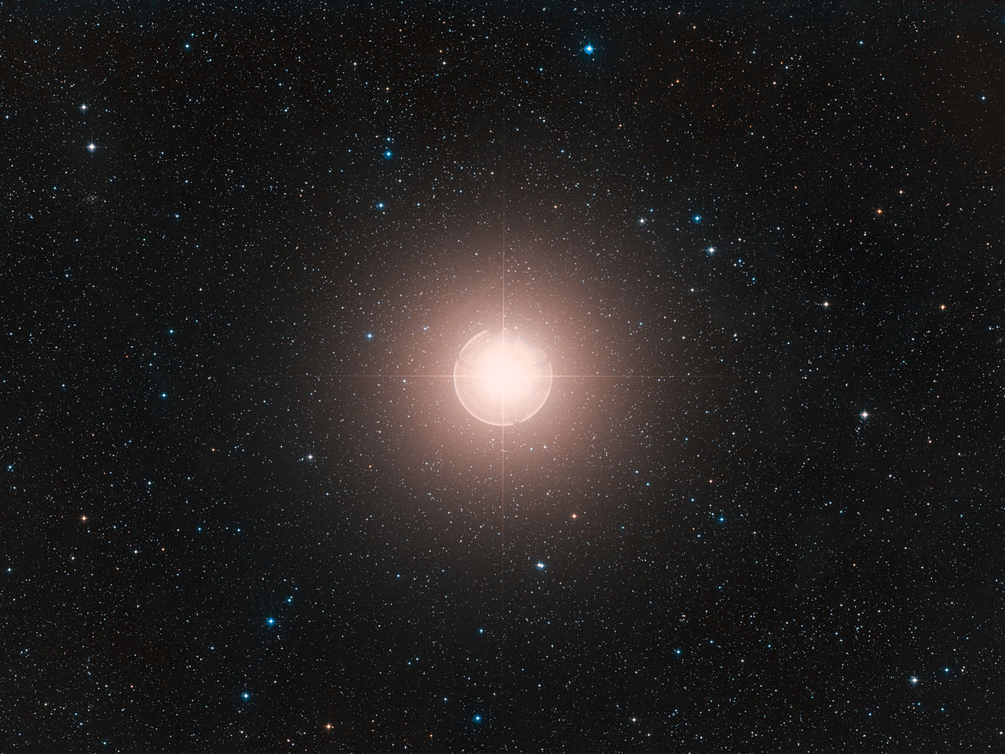

Distant Stars exercise

Using the H-R Diagram, estimate the intrinsic luminosity for Rigel.

Here are the basic luminosity classes:

Luminosity class | Description
I | Supergiant
II | Giants
III | Normal giants
IV | Subgiant
V | Main-sequence (dwarf) star

Rigel has a temperature of 12000⁰ and a luminosity class of I.



